Python Fundamentals & Problem Solving – Day 1 Submission
Name: Vanamala Jayasurya
Date: 06 September 2026
Day: 1

Coding Problem — First Non-Repeating Character
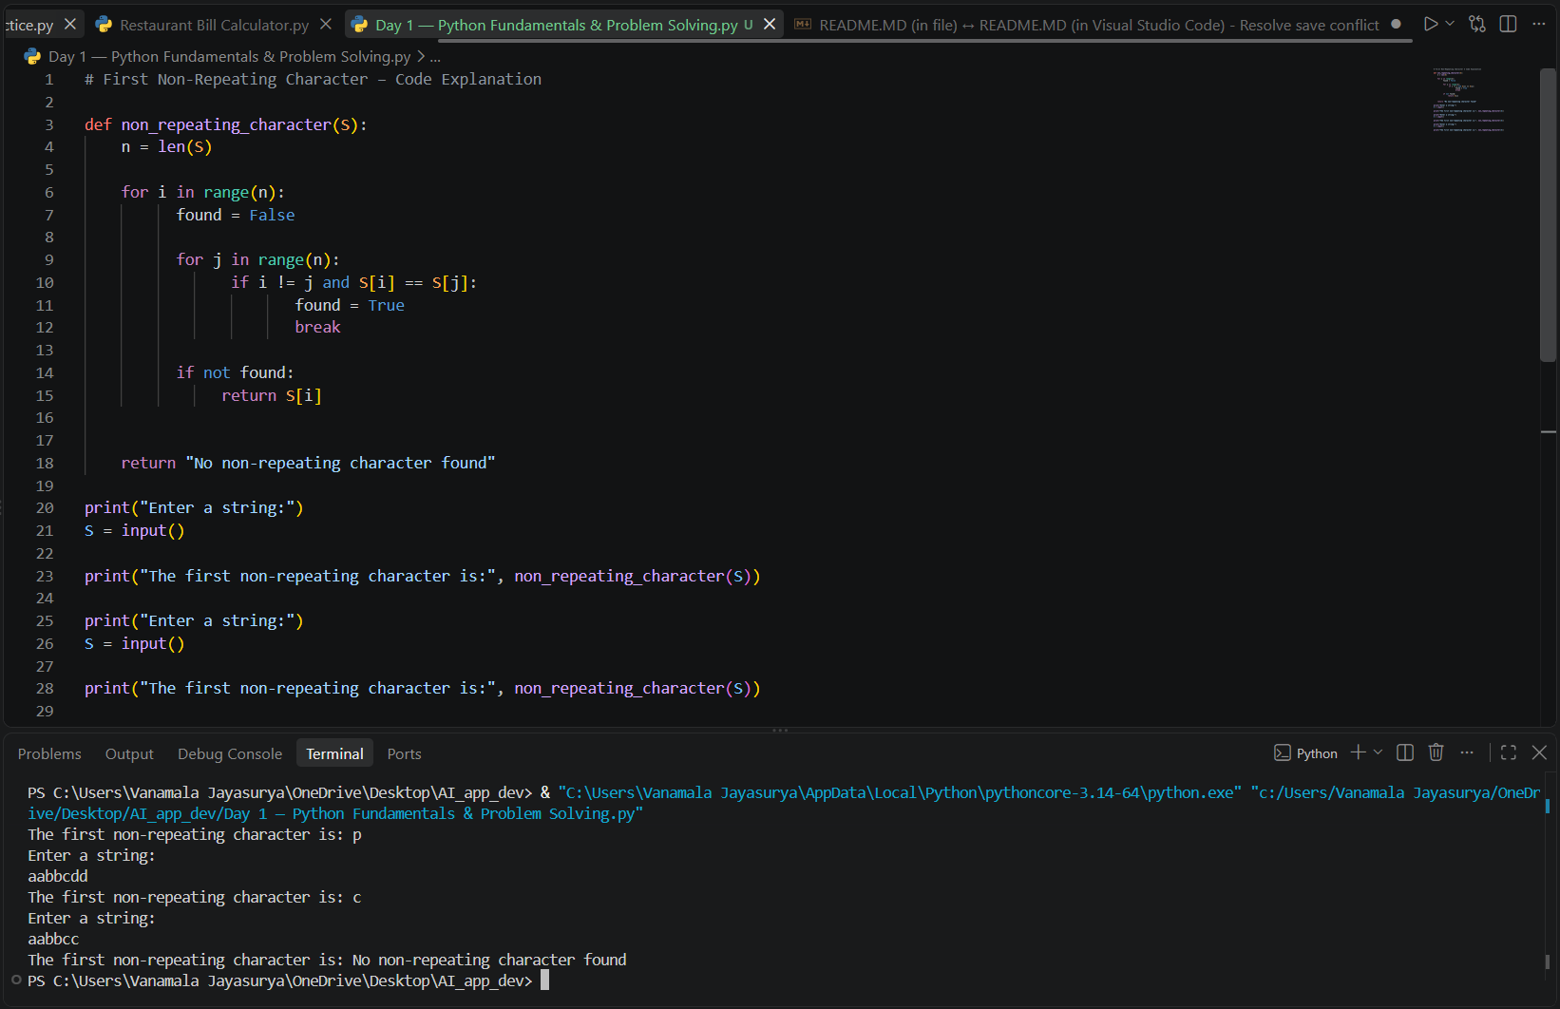

Coding Problem — First Non-Repeating Character

Data Structure | Ordered? | Duplicates? | Mutable? | Example
List | yes | yes | yes | [ 1,2,3]
Tuple | yes | yes | no | (1,2,3)
Set | no | no | yes | 123
Dictionary | yes | no | yes | { name : “jay” ,age :”22” }

Interview Follow-up

1. If you need to store unique student IDs, which data structure would you choose and why?
Set it does not store the duplicates values

2. If you need to store a student's name, email, and phone number together, which data structure would you choose and why?
Dictionary it stores the together as pairs

3. Debugging Challenge

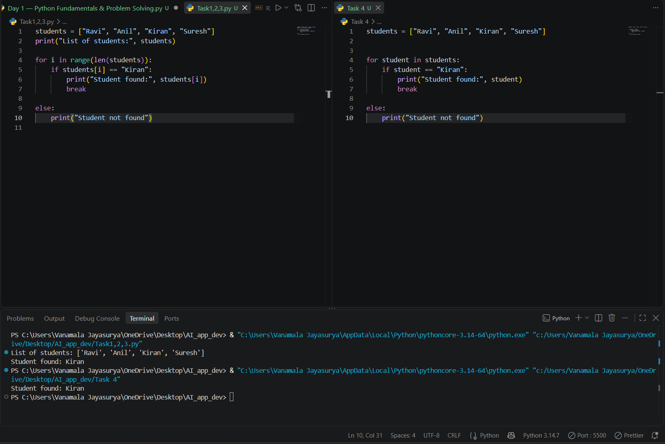
- Is there a problem with the output?
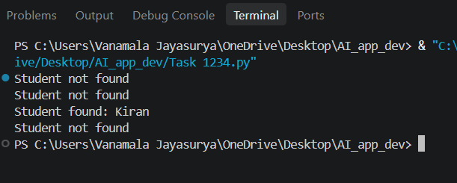
Yes student not found it can 3 times
- Why is "Student not found" printed multiple times?
Beacause Else is not in right place
- Modify the code so it prints "Student found: Kiran" if Kiran exists, otherwise "Student not found"

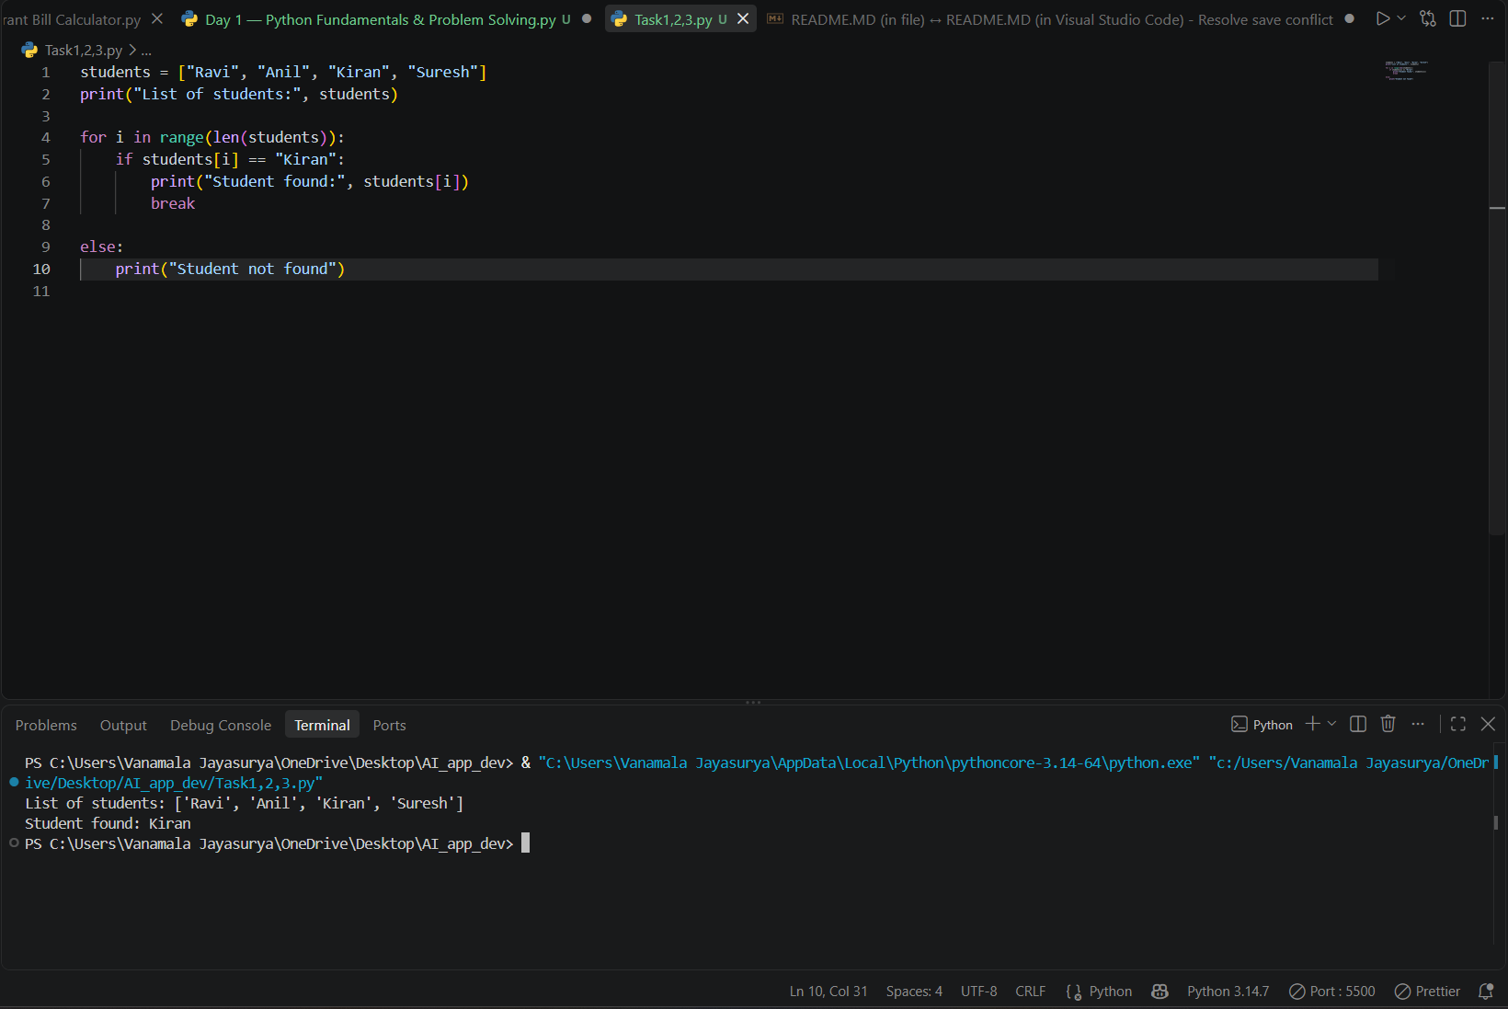

4. Bonus: Can you solve it without using range(len(students))?

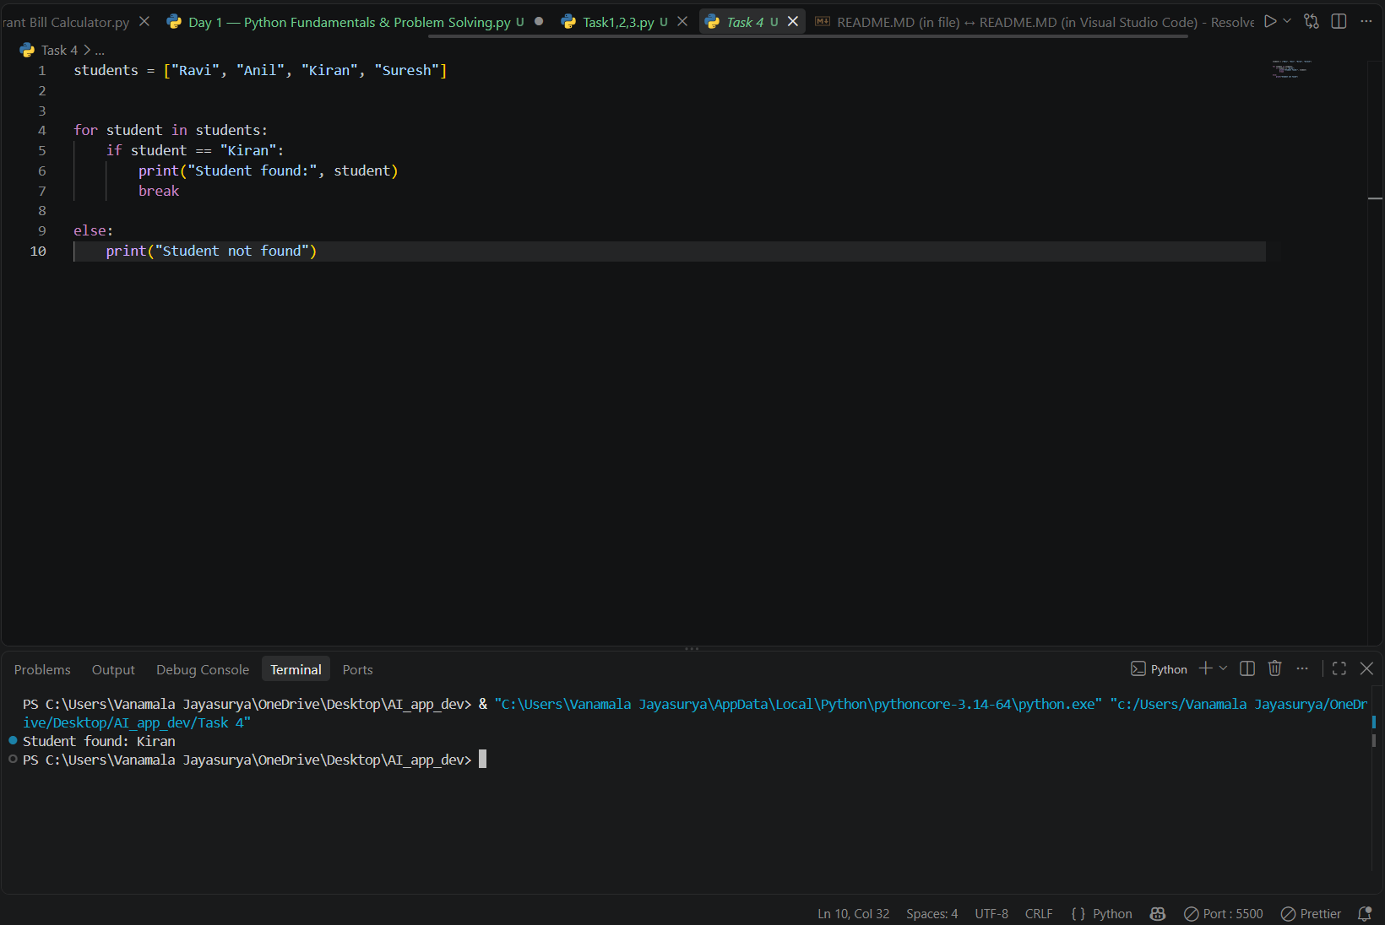

- What I learned today:
- Lists
- Tuples
- Sets
- Dictionaries
- for loop
- if-else
- break statement
- Debugging Python code

- What I found difficult:
Try not to use count() inside a loop.
Can you explain the time complexity of your solution? Try to design a solution that does not repeatedly scan the string for every character
Bonus: Can you solve it without using range(len(students))?

